MSC
The main task of MSC is to co-ordinate the call set up between two mobile GSM users or between a GSM user and a user of an external network such as PSTN, ISDN. This task is realized, by among another users by performing the following functions
- Calling the user setting up and maintaining a connection
- Dynamic network resource management in the system area managed by MSC
- Rerouting of the connection to a new call server by a Base System controller (BSC) different from the controller which supervised the cell with in which MS has been operating so far called as hand over
- Performing the interface with other networks
- Re-assignment of the BTS carrier frequencies in order to redistribute the network resources with regard to the particular load and local part of the network
Information Exchange between MSC and BSS is normalized by defining the so-called A interface, where A_{bis,} interface standardizes the data exchange between the base station controller and its transceivers
The A interface mainly deals with network and switching aspects, for ex: with the functions performed by MSC, HLR and VLR with management of fixed links with network management, controlling and encryption of user data and signaling information with management resulting from the necessity of MS authentication and location updating caused by MS geographical movement and with management due to calling the users.
The A_{bis,} interfaces is associated with the information exchange related to the radio transmission, such as the distribution of radio channels, connection supervising, the queuing of messages before transmission, carrier frequency hopping control, if applied, the channel coding and decoding, the coding and decoding of speech signals, message encryption and radiated power control
The rules of information exchange between BTS and MS are normalized by the definition of the radio interface denoted by U_{m}.
The operation and maintenance centre (OMC) supervises the operation of the particular GSM system blocks. It is connected with all the switching blocks of the GSM system and performs management functions such as tariff accounting, traffic monitoring, management in case of failures in particular network blocks. One of the most important tasks of OMC is HLR management. In case of large networks there are more than one OMC and the whole network is managed by NMC (network management centre).
The communication between OMC and network blocks is realized by a special communications management network implemented by leased telephone links or other fixed networks. Message transfer is performed by SS7 signaling protocols and x.25 protocol for A and A_{bis,} interfaces, Some of the interfaces are also denoted by C,D,E. they are normalized by ETSI/GSM standards and set the message exchange rules between particular blocks of the signaling network. These interfaces, although important at the moments of the connection set-up and connection re-routing between different MCSs, are outside our interest.
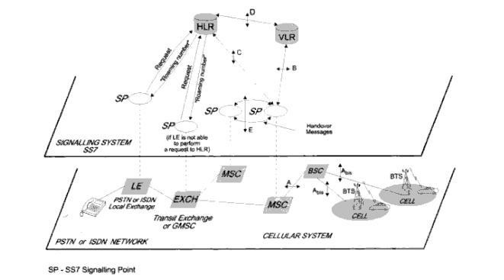

If MS is not on call:
The method of transferring calls from a first station of a first telecommunications network (PSTN) including integrated call transfer means to a mobile station connected to a radio communications network. An auxiliary device is intended to automatically trigger a call transfer activation and/or deactivation control by transmitting predefined messages from the auxiliary device which have integrated network transfer means (PSTN) for their destination. The auxiliary device may advantageously be used in a charger of a mobile station and thus it includes detection means for detecting the presence of the mobile station for automatically triggering a call transfer when the station does not rest on its charger.

Please Note: I have shared my view that’s it.

