GSM Network Architecture
The GSM Architecture consists of three major sub-systems. These are Base Station Sub-System (BSS) that provides the air interface for Mobile Stations (MS), Network Sub-System (NSS) that connects calls between users, and Operation Sub-System (OSS) that allows remote monitoring and management of network.
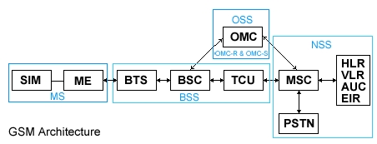
SIM - Subscriber IdentityModule, ME - Mobile Equipment, BTS - Base Transceiver Station, BSC - Base Station Controller, TCU - Transcoder Unit, MSC - Mobile Switching Centre, PSTN - Public Switched Telephone Network, HLR - Home Location Register, VLR - Visitor Location Register, AUC - Authentication Centre, EIR - Equipment Identity Register, OMC - Operations & Maintenance Centre, OMC-R - OMC devoted to BSS, OMC-S - OMC devoted to NSS.

Base Station Sub-system (BSS)
The Base Station function is divided into two main functional elements, the Base Station Controller (BSC) which also includes the Transcoder Unit (TCU), and the Base Transceiver System (BTS).
The BSC can control several BTS units. Each BTS will consist of a number of transceivers (TRX) and will serve a cell or a number of cells. The BSC unit also performs transcoding functions to convert between 64Kbps channel rate used in the Switching System and the 16Kbps channel rate for GSM traffic.

Network Switching Sub-system (NSS)
The switching system connects mobile subscribers to other mobile subscribers in the same network or to other networks. To perform this function a number of Mobile Switching Centres (MSC) are employed. However to connect to users on another network requires a Gateway MSC (GMSC) which provides interconnection between different networks.
Associated with the MSC are location registers and authentication functions that allow the network to locate and validate system users. There is one Home Location Register (HLR) and Authentication Centre (AUC). However, each MSC has a Visitor Location Register (VLR) associated with it.

Operation Sub-System (OSS)
The OMC provides remote monitoring of the network performance and permits remote re-configuration and fault management activity as well as alarm and event monitoring.

Mobile Station (MS)
The MS comprises of Mobile Equipment (ME) and a Subscriber Identity Module (SIM). The ME contains the software and hardware to operate as a mobile radio terminal. The SIM in conjunction with the network Authentication Centre (AUC) validates the MS.

UMTS Network Architecture
One of the requirements for the Release 99 Architecture is to support roaming and inter-operation with the GSM system, hence the GSM system appears as one of the components of the UMTS Release 99 Architecture.
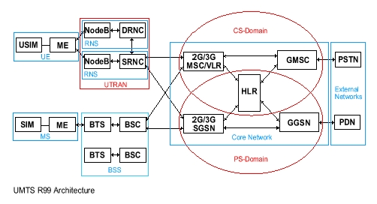
USIM - UMTS Subscriber Identity Module, UE - User Equipment, Node B - UMTS Base Station, SRNC - Serving Radio Network Controller, DRNC - Drift Radio Network Controller, SGSN - Serving GPRS Support Node, GGSN - Gateway GPRS Support Node, PDN - Public Data Network, SIM - Subscriber Identity Module, ME - Mobile Equipment, BTS - Base Transceiver Station, BSC - Base Station Controller, MSC - Mobile Switching Centre, GMSC - Gateway Mobile Switching Centre, PSTN - Public Switched Telephone Network, HLR - Home Location Register, VLR - Visitor Location Register.

CS-Domain
This is the Circuit Switched domain that is traditionally known to provide services such as speech calls. The Core Network (CN) component that implements the CS services for UMTS is the 3G-MSC.

PS-Domain
This is the Packet Switched domain that is known to provide services such as IP Based traffic. The CN component that implements the PS services for UMTS is the 3G-SGSN.

UMTS Terrestrial Radio Access Network (UTRAN)
This consists of the Radio Network Controller (RNC) and the Node B. The UTRAN is responsible for functions that relate to access, radio mobility and resource utilisation. The Serving Radio Network Controller (SRNC) is responsible for the logical connection between the UE and the CN. The Drift Radio Network Controller (DRNC) provides additional radio resources for a UE that is in a dedicated connection and a soft-handover state. The Node B that is attached to the DRNC will provide the physical resource to the UE, and the information on the uplink and the downlink is routed towards the SRNC.

User Equipment (UE)
The radio terminal that the subscriber uses to receive service from the UTRAN is known as the UE. This will arrive in the form of PDA terminals and Handsets similar to current GSM mobiles. The UE's will be supporting multimode GSM, GPRS and UMTS services. They will be supporting multi-band GSM900, DCS1800 and PCS1900 systems. The capabilities of these User Equipments will vary hence the UTRAN will read UE capabilities during set-up.

