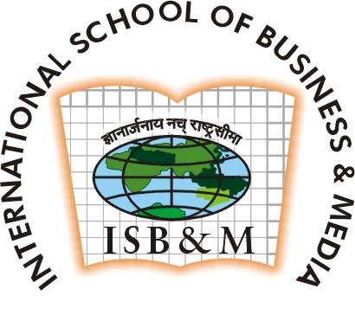

Summer intership Programme (2007-2008)

International School of Business & Media, Kolkata

Post Graduate Programme in Business Management
Specialisation:MARKETING &RETAIL.
Name : Amrata Tripathi
Contact Address : International School of Business & Media,
EN-22, Sector V, Salt Lake City, Kolkata-91.
Permanent Address : 128/26 ‘B’ Block Kidwai Nagar KANPUR 208011
Phone : 033-66131240
E- mail : placements@isbm.ac.in, placements_isbmkolkata@rediffmail.com

Education

International School of Business & Media, Kolkata 2007-2009

Pursuing

College Name:Christ Church College Kanpur 2004-2007
B. Sc ( Physics,Chemistry,Math’s) 51%

School name:Rahul Memorial Inter College Kanpur 2004

UP Board 66%

School Name: MG Inter College Kanpur 2000
UP Board 52%

Work Experience NIL

Projects & Live Assignments N.A.
- Marketing Project on RAYMOND
- Marketing project on(launching an internet portal)
- Finance Project on PANTALOON
- Retail project (comparative study b/w vishal mega mart,subhiksha&cerrefore,bloomsberry)
- Business communication project on Hiring and retaining employees)
- Service marketing project(Launching a service for old age people their children are NRI)

Awards & Achievements

Selected as the House Captain in 10th.
Winner in college debate.

Extra Curricular Activities

Participating in Debate.
Participating in Quiz Contest
Taking part in sketching ,drawing and other creative activities.

COMPUTER PROFICIENCY

Computer literate.
MS- Word,
MS- Excel,
MS- Powerpoint.
MS- Access

MOTTO IN LIFE

“I WILL TOUCH THE HEIGHT AFTER A BOUNCE”

Date of Birth:26.06.1986 Name:AMRATA TRIPATHI

