1)

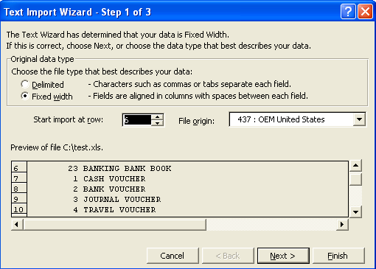

2)

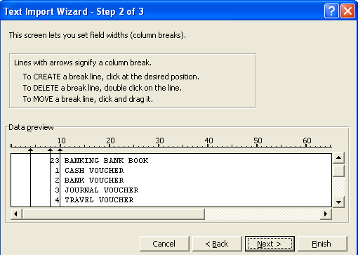

Move the Arrow lines to separate the columns

3) Then Finish

